CLOUD TRAIL
1 . Enable cloudtrail monitoring and store the events in s3 and cloudwatch log events
- Aws console
- navigate to cloudtrail
- create a trail > new s3 bucket > enable log file validation
- enable sns
- 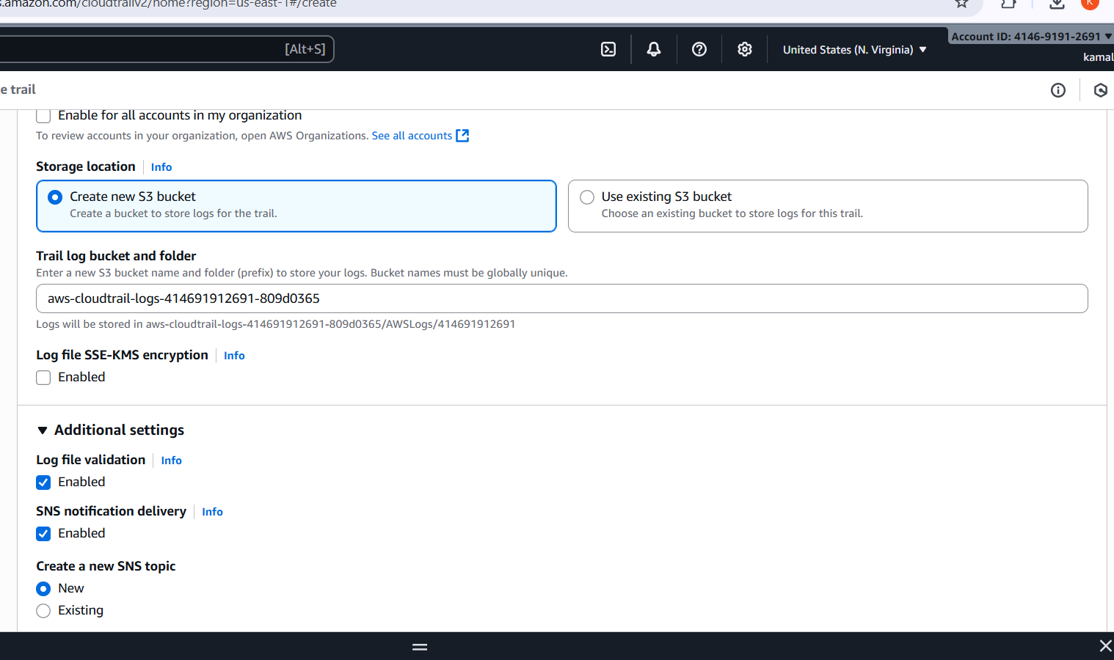
- Select new log group
- Give new IAM ROLE

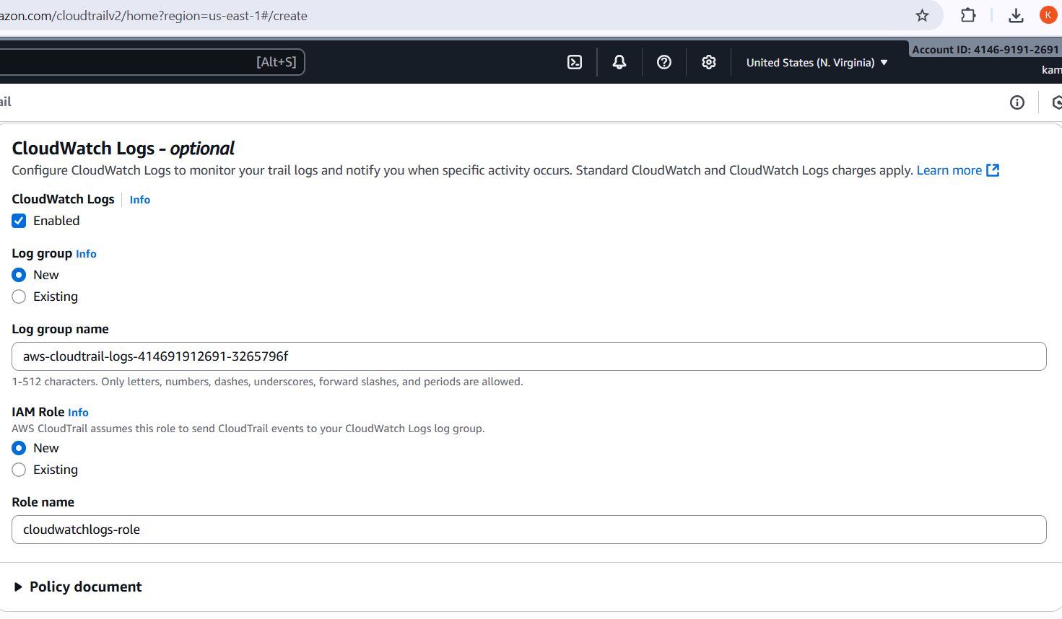
Enable management and read and write
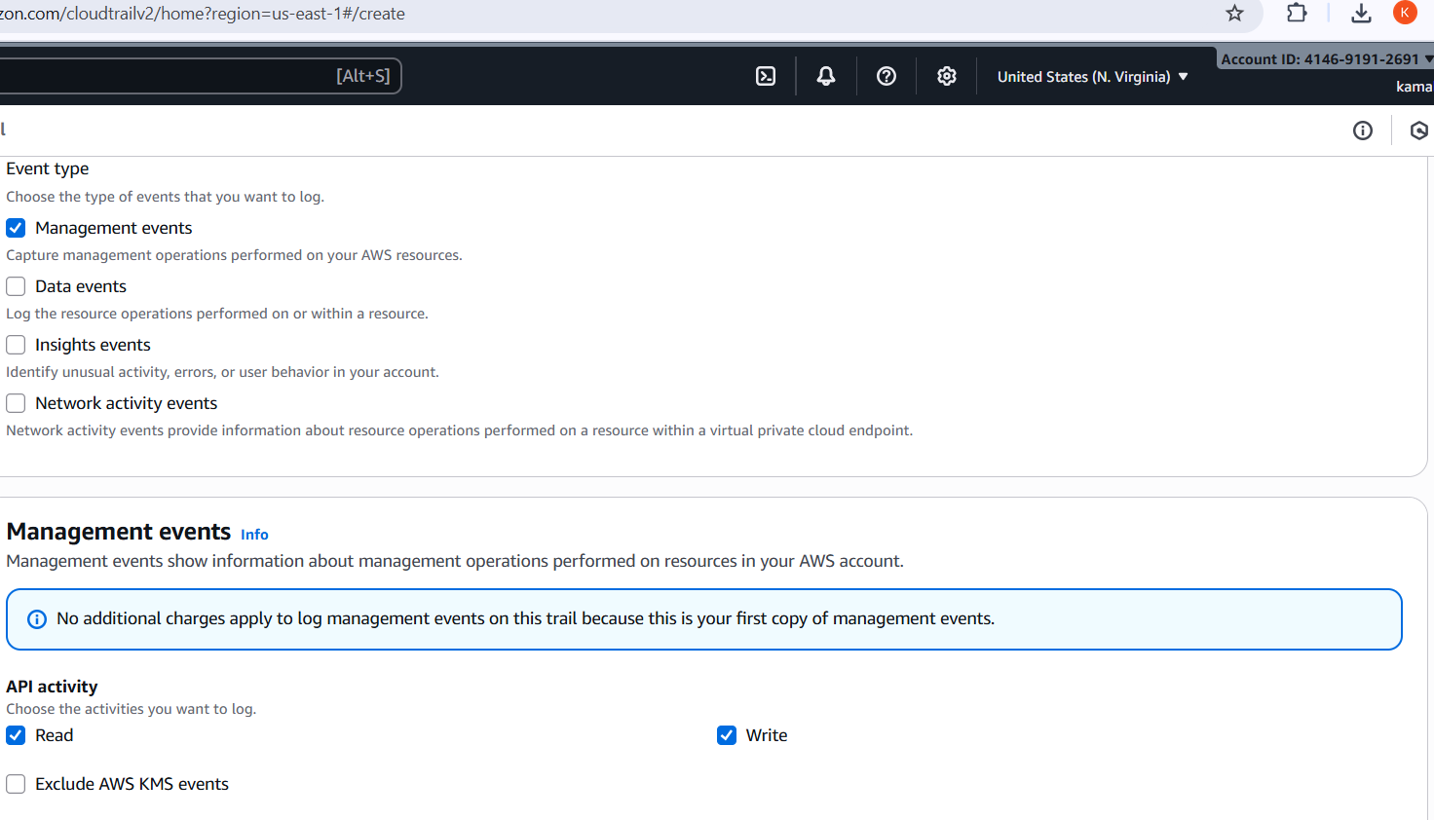
- Created a trail
- 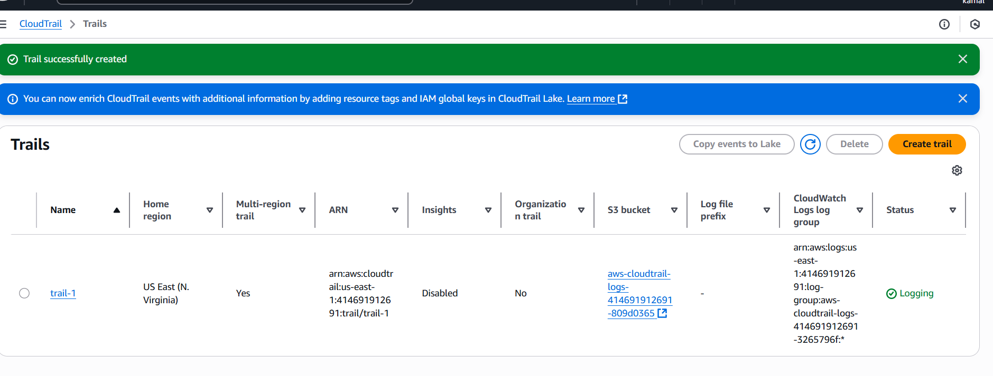
- Now navigate to cloudwatch
- On the left side click logs > logs groups
- 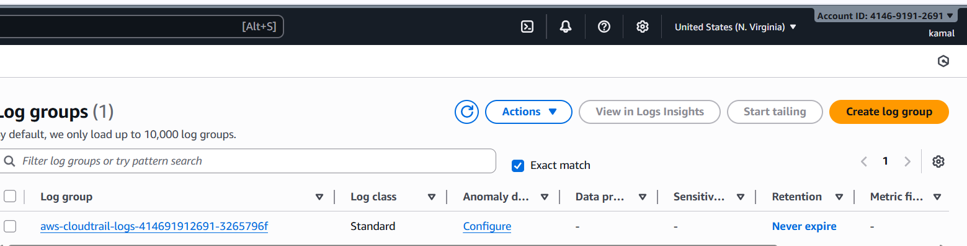
- Logs are created
- 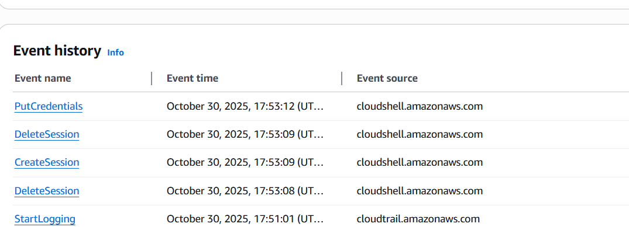
- Now navigate s3 and we can able to see logs being stored in s3 bucket also
- 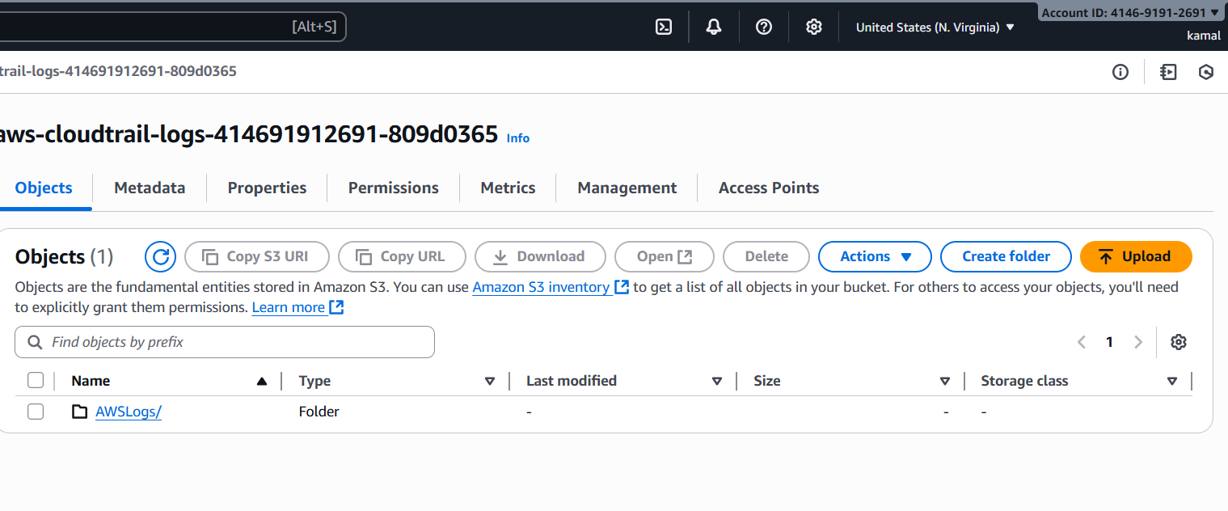
- CloudTrail is successfully connected to CloudWatch Logs.’
2 . Enable SNS for cloudtrial to send alert on email.
- Cloud trail > cloud watch >
- Click log groups

- Create a bucket
- Add objects in to it
- Create a topic in sns add gmail to it
- 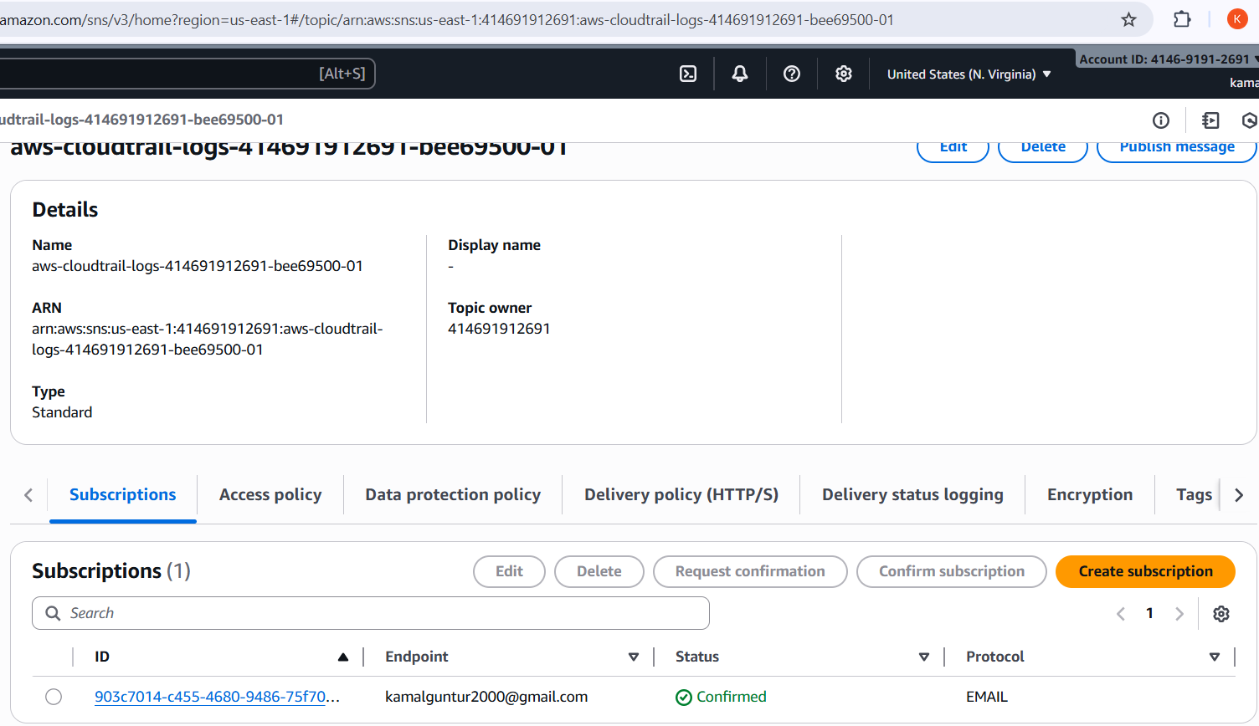
- Accept the subscription req in gmail
- 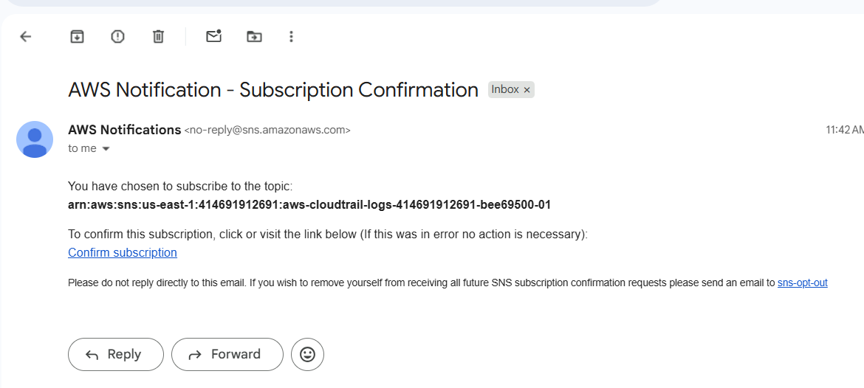
- When ever any action has been taken in s3 will get notification through gmail
- 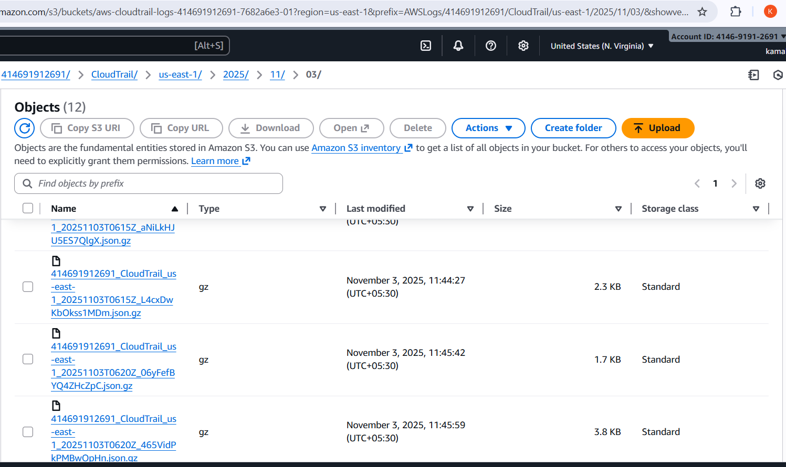
- Recived notification in gmail
- 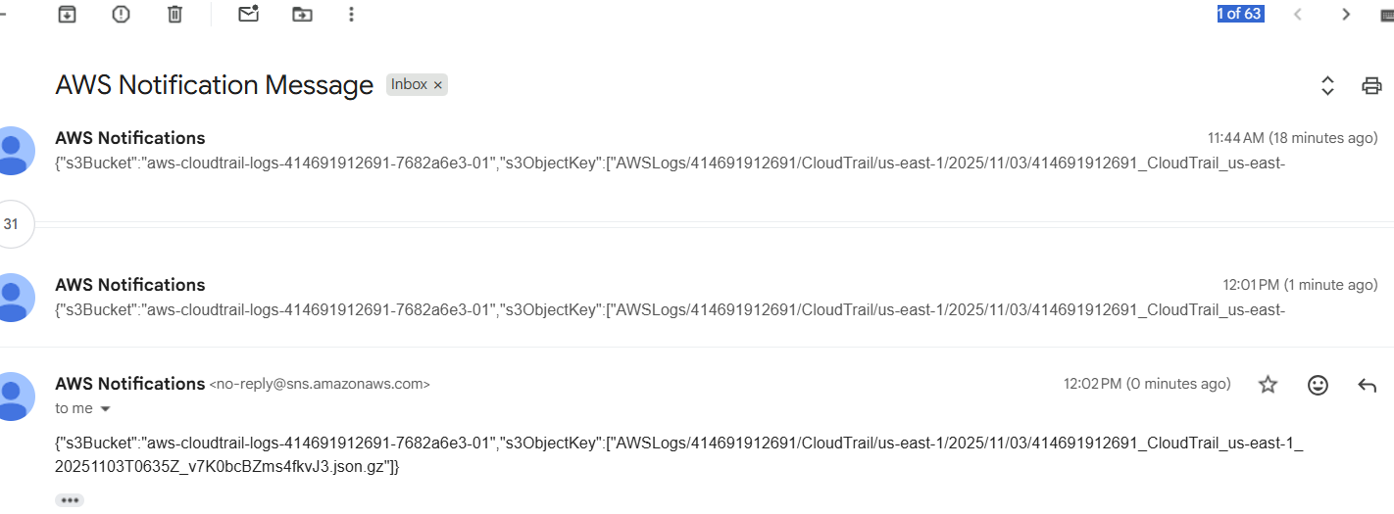
- 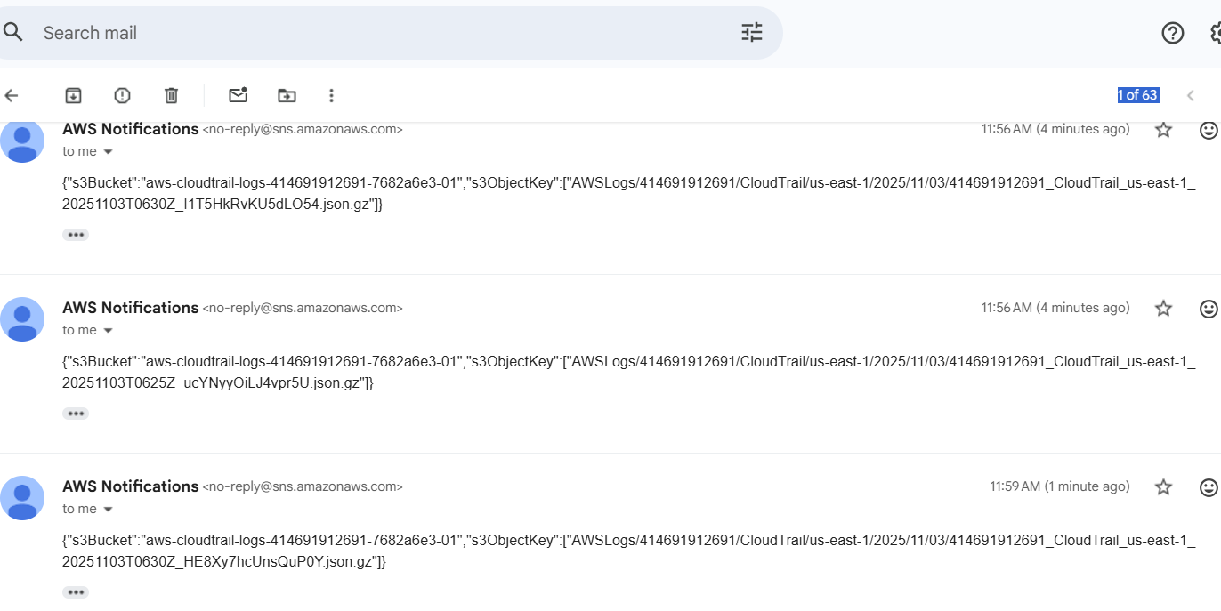
3 . Configure cloud watch monitoring and record the cpu utilization and other metrics of ec2.
- Go to ec2
- Below the instance we can see monitioring option
- 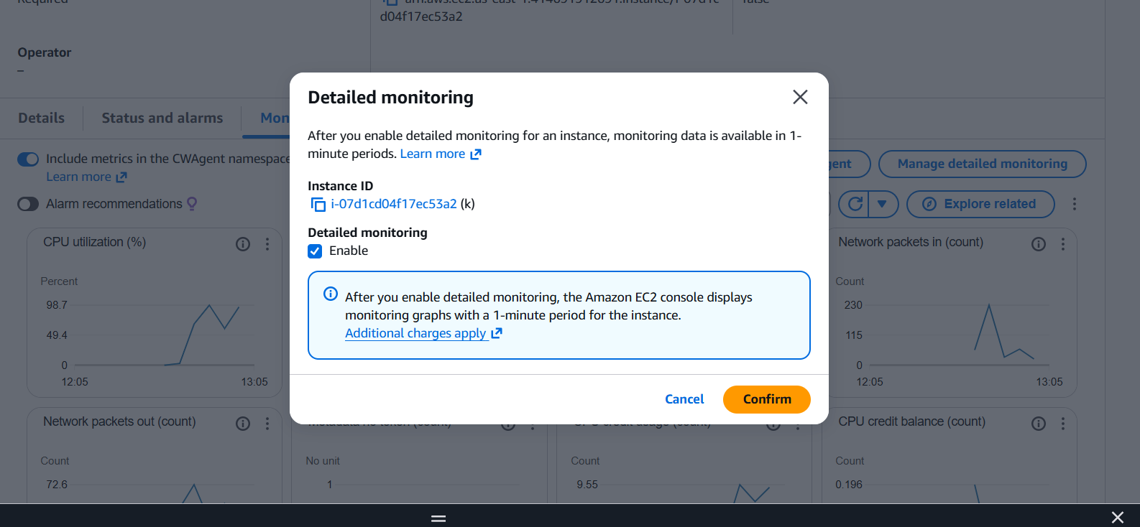enable it
- Now enlarge the cpu utilization and launch the instate , wait for 3?3 check passed
- Now connnec to terminal and add heavy load ion instance by using commands
- 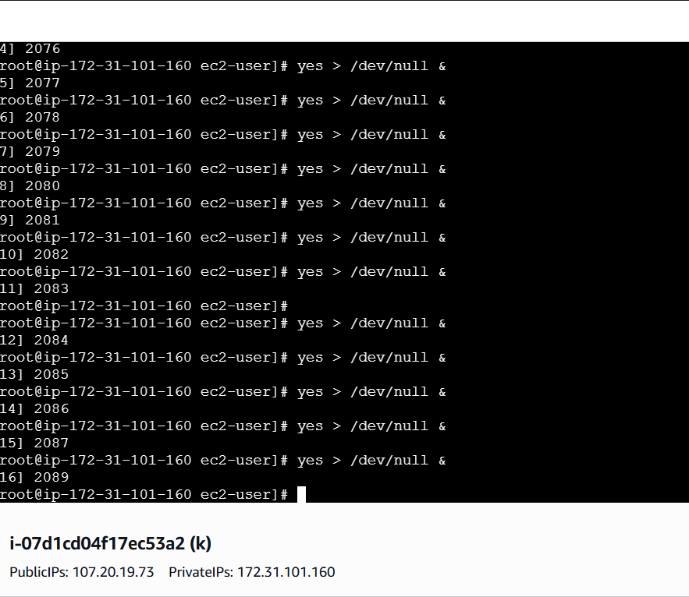
- Can see the cpu utilization in cloud watch
- 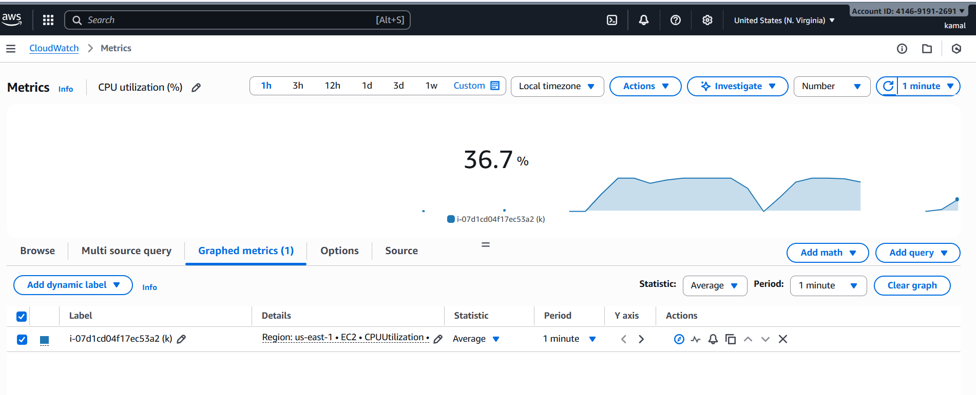
4 . Create one alarm to send alert to email if the cpu utilization is more than 70 percent.
- Navigate to cloudwatch dashboard,
- Create one
- Add metrics
- Add ec2
- 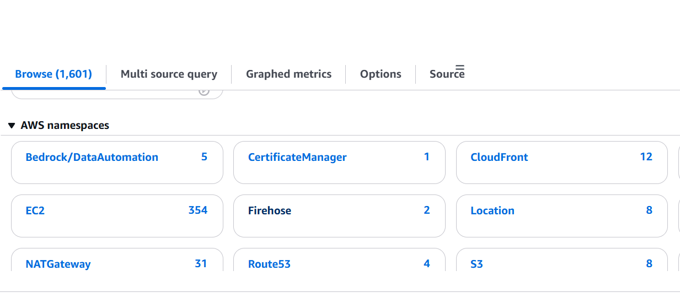
- And pre instancemetrics
- Copy instance id from ec2 instacne dashboard and paste in pre instance metrics
- Search for cpu utilization
- Increase load in instance with load commands
- 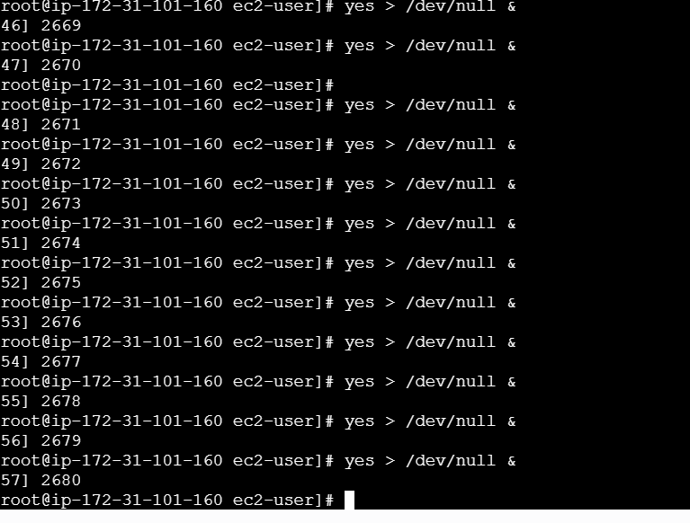
- Automatically load increase can visible in cpu usage graph
- 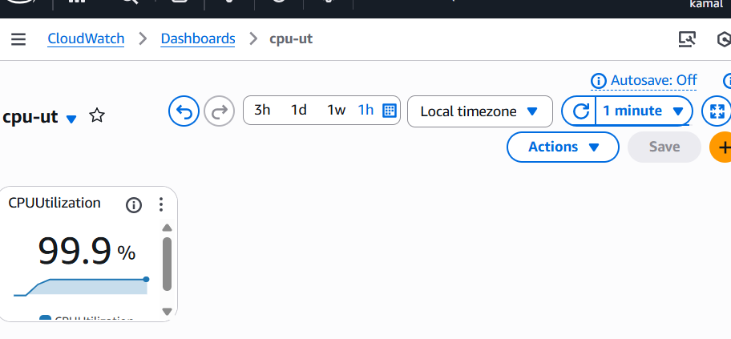
- Now set an alarm if the usage above 70%
- Also add sns for notification
- Navigate to alarm
- Create an alaram add ec2 and instance id in
- 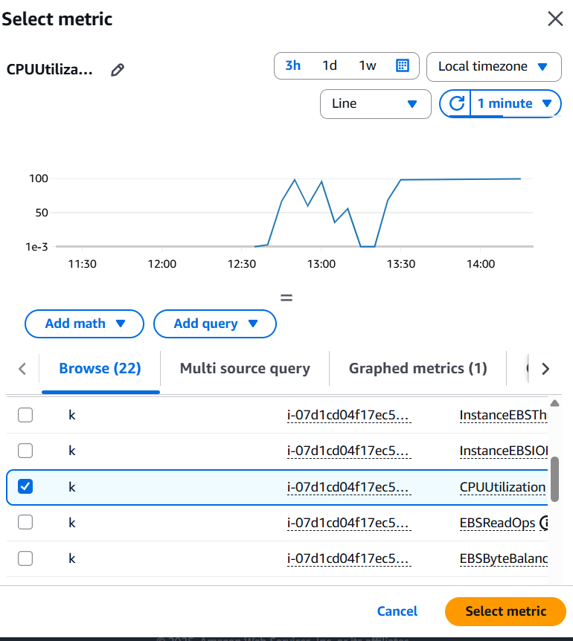
- Give thresholdvalue 70
- 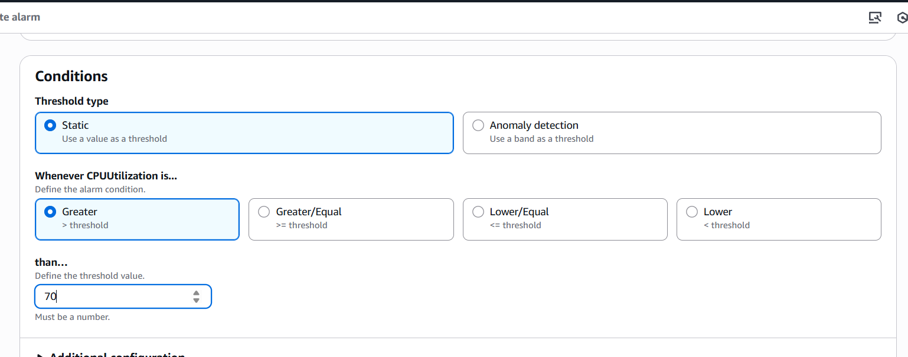
- Select in alarm
- Add sns topic
- Attach email for notification
- If cpu utilization is more than 70 will mail as an alarm
- 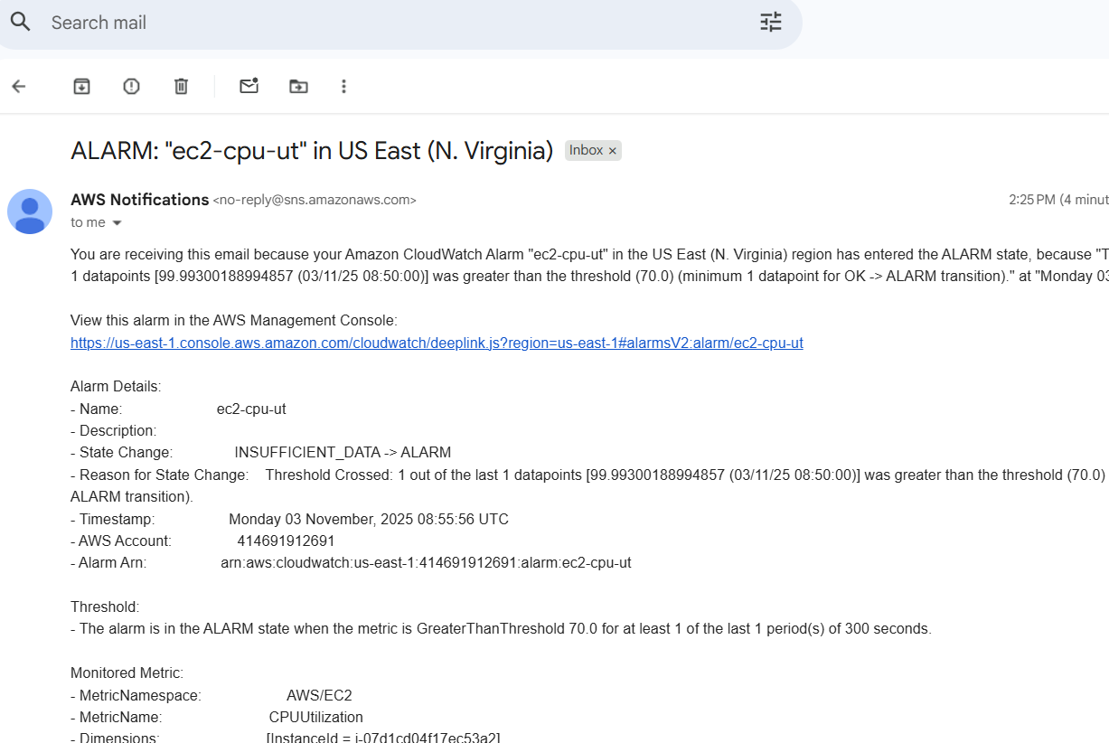
- Now create SECOND ALARM for if CPU USAGE IS less than or equal to 70 , than CPU IS OKAY
- Configuration ok , isf cpu usage is less than or equal to 70

If alarm send an notification , also we can add rule to alarm , it gets terminated when cpu usage crossed 70 .
- Now create a rule by navigating to AMAZON EVENTBRIDGE
- Click rule select
- • Under “Event source”, select:
➤ Event pattern (not schedule)
- Choose event pattern:
- Event source: AWS services
- AWS service: CloudWatch
- Event type: CloudWatch Alarm State Change
- 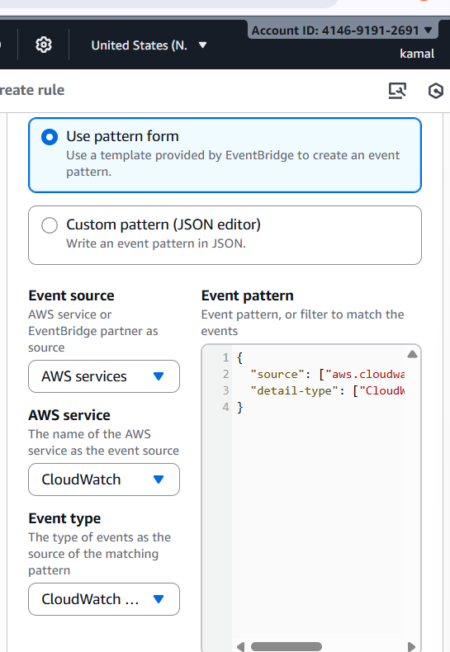
- In the TARGET SECTION add aws service
- Target – EC2 TERMINATION API
- ADD INSTANCE ID
- Select create a new role for this specific resource
- 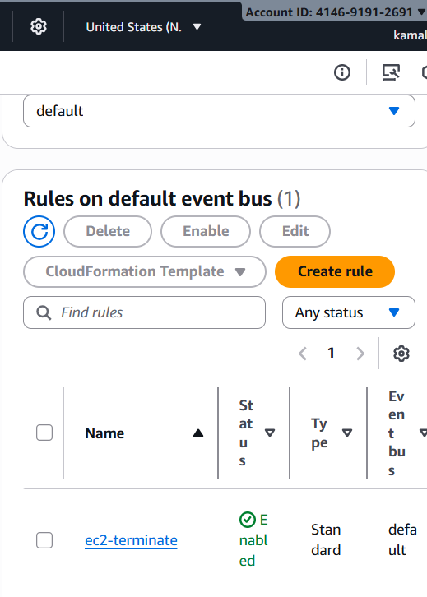
- Rule created successfully

5 . Create Dashboard and monitor tomcat service wether it is running or not and send the alert.
- To get alert about service running in instance we need to install cloud agent in CLI
- sudo yum install amazon-cloudwatch-agent -y
- and install tomcat
- now,
- 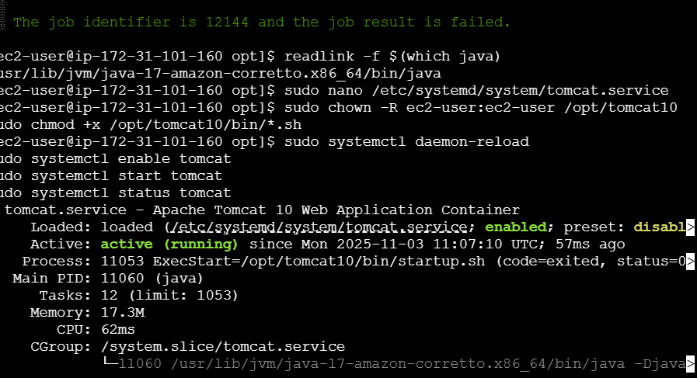
- Install cornjob in CLI
- sudo yum install cronie -y
- now go to aws console
- cloud watch > select all metrics
- choose custom tomcat
- 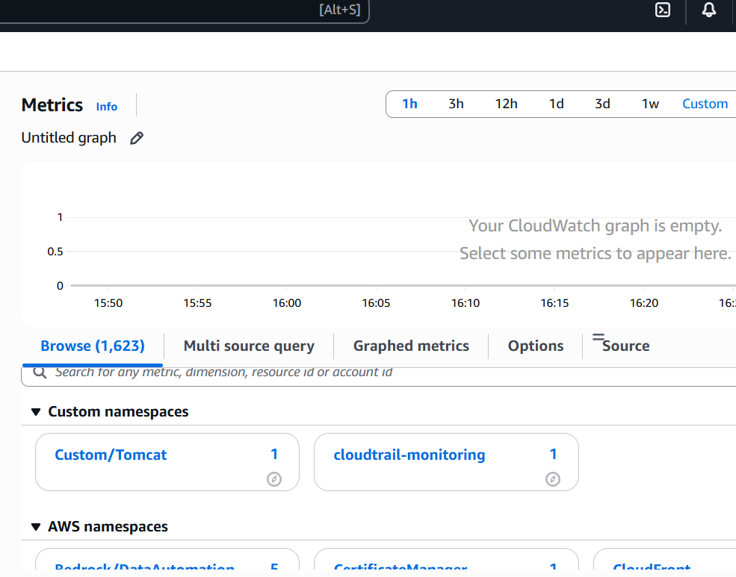
- Create a dashboard as tomcat-monitor

- 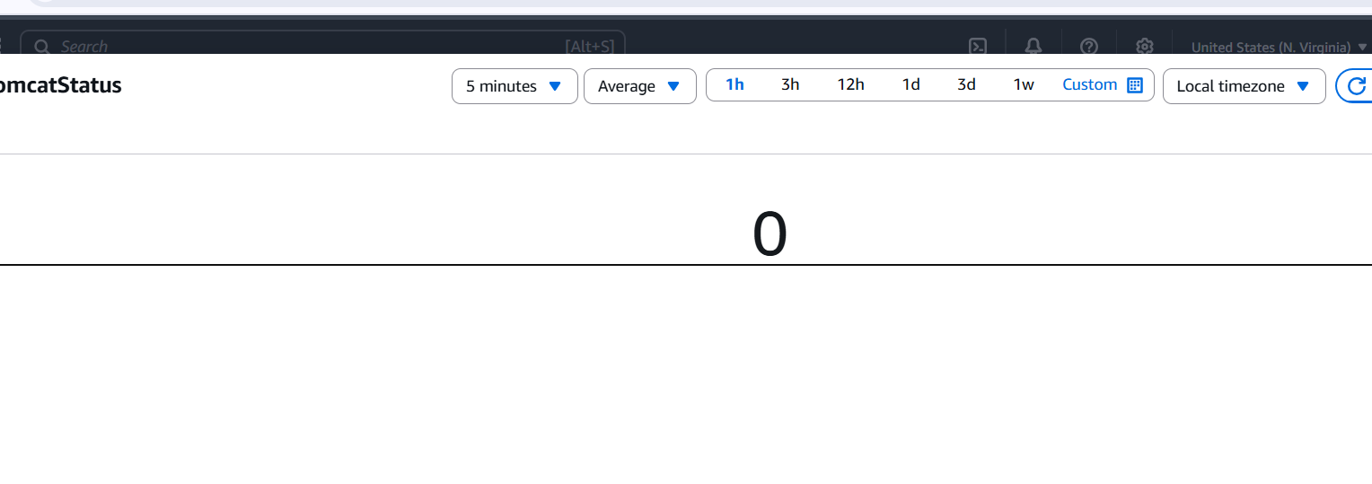
- Navigate to sns create a topic add
- Email id and create subscription
- 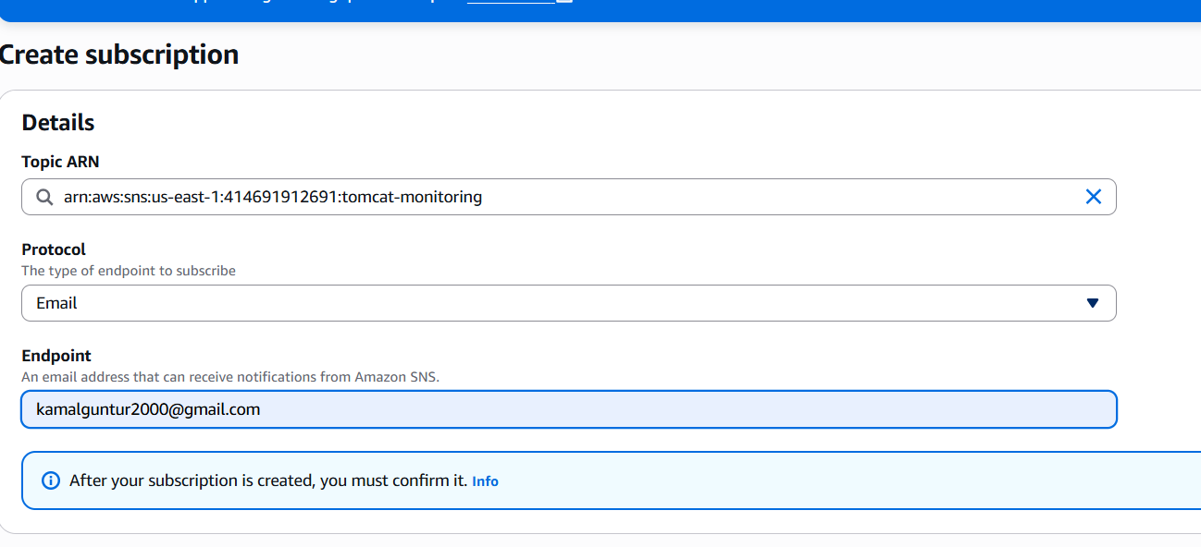
- Create a ALARM add tomcat to it
- 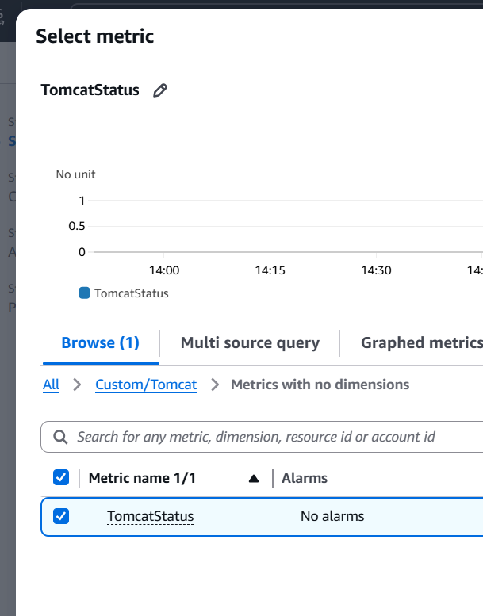
- Recived mail , when apache started running
- 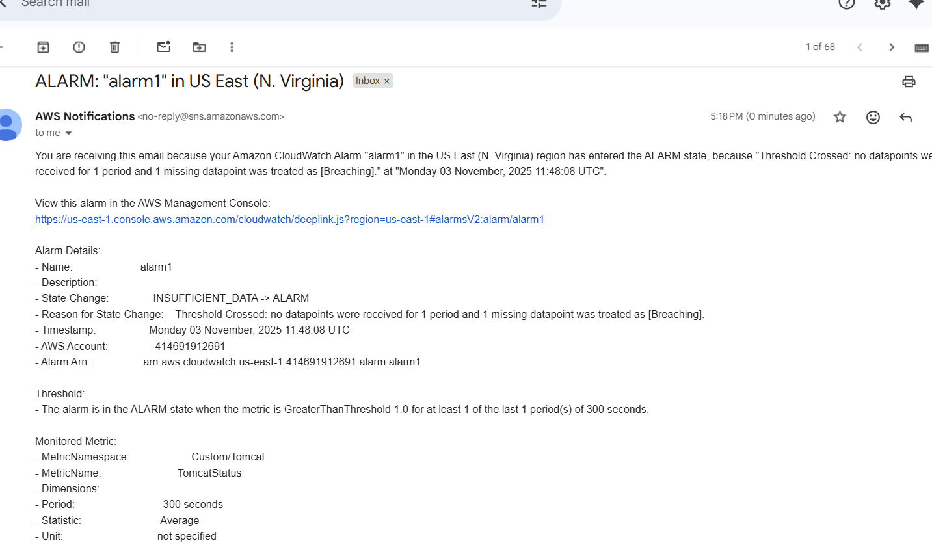
6 . Create Dashboard and monitor nginx service to send the alert if nginx is not running.
- Install nginx in cli
- Add a script to file
- sudo mkdir -p /opt/scripts
- sudo nano /opt/scripts/nginx-metric.sh
- add script
- #!/bin/bash
- SERVICE="nginx"
- NAMESPACE="Custom/Nginx"
- METRIC_NAME="NginxServiceStatus"
- LOGFILE="/home/ec2-user/nginx-metric.log" # change if needed

- STATUS=$(systemctl is-active $SERVICE 2>/dev/null || echo inactive)

- if [ "$STATUS" = "active" ]; then
- VALUE=1
- else
- VALUE=0
- fi

- # send metric
- aws cloudwatch put-metric-data \
- --namespace "$NAMESPACE" \
- --metric-name "$METRIC_NAME" \
- --value "$VALUE" \
- --unit "Count"

- # log locally
- echo "$(date -u): Sent metric $METRIC_NAME=$VALUE (status=$STATUS)" >> "$LOGFILE"
- install cornjob
- sudo yum install cronie -y
- add script to corn = crontab -e
- now add
- * * * * * /opt/scripts/nginx-metric.sh >/dev/null 2>&1
- Configure aws
- Now in GUI nignx is available
- 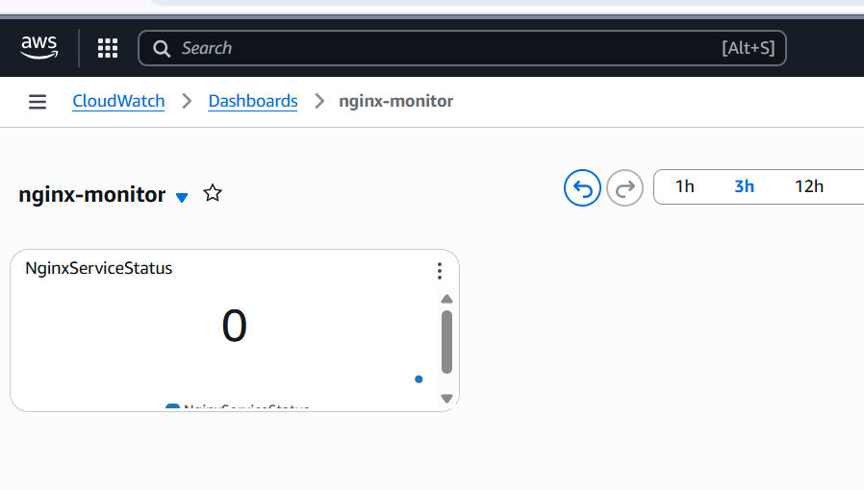
Now create 2 alarm for nginx
- Less than 1 threshold
- Greater than 1 threshold
- Add endpoint for sns notification
- 